April 20, 2026
Natalia Gutiérrez Sánchez
Lasalle college
Computer Tools
The internet of things (iot)
Report
Table of Contents
Introduction 0
What does IoT mean? 1
Which technologies make IoT happen? 3
Examples of IoT applications 4
Pros vs. Cons of IoT 5
The future of IoT 6
Conclusion 7
Bibliography 8

Introduction

In these times, almost every device and gadget we use can be connected wirelessly somewhere, whether if it is to Wi-Fi, Bluetooth, amongst other possible connections. In this report, I would like to dig deeper into the importance that the Internet of Things (IoT) withholds, mainly on computer science technology fields.

Through the length of my report, I will define the concept, give some examples to increase understanding, explore the different alternatives that a device could employ IoT, evaluate the pros and cons of IoT and finally, the advances that IoT has had over the time. I will also be summarizing everything briefly in the conclusion of this same report.

What does IoT mean?

The Internet of Things (IoT) refers to a network of physical devices, vehicles, appliances, and other physical objects that are embedded with sensors, software, and network connectivity, allowing them to collect and share data.

IoT devices—also known as “smart objects”—can range from simple “smart home” devices like smart thermostats, to wearables like smartwatches, to complex industrial machinery and transportation systems.

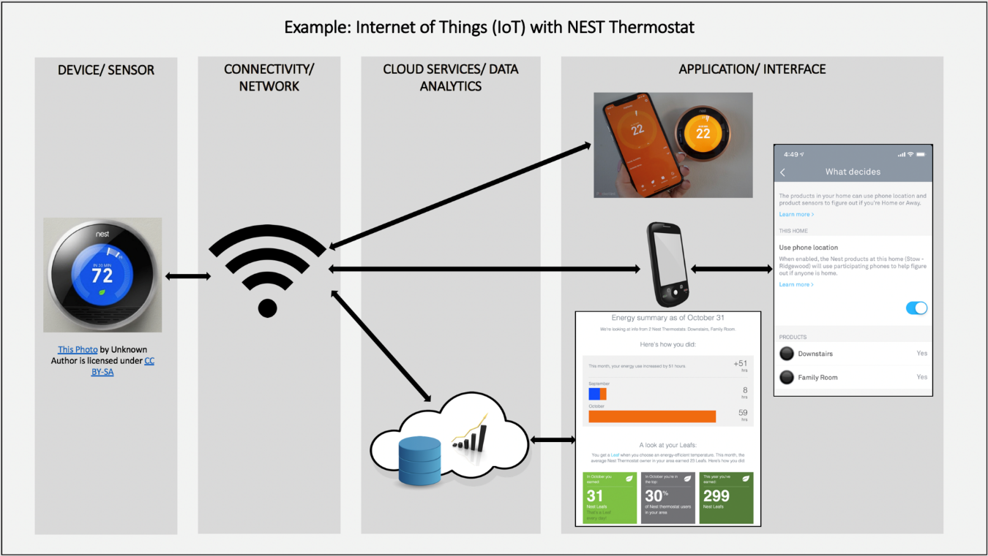
Figure 1- Example of how IoT is used to connect a thermostat to the internet

  - What can IoT do on these devices?

IoT enables these smart devices to communicate with each other and with other internet-enabled devices. Like smartphones and gateways, creating a vast network of interconnected devices that can exchange data and perform various tasks autonomously. This can include:
- monitoring environmental conditions in farms
- managing traffic patterns with smart cars and other smart automotive devices
- controlling machines and processes in factories
- tracking inventory and shipments in warehouses

  - Core Relationships Between IoT and Computer Science
Networking & Communication Protocols: CS defines the rules (protocols) for how IoT devices communicate over the internet or local networks. | Cloud & Edge Computing: CS enables architecture that decides whether data is processed locally (Edge/Gateway) or in the cloud for efficient operation.
Data Processing & Big Data: IoT devices generate vast amounts of data. Computer scientists build systems to manage, store, and analyze this data in real-time to generate insights. | Artificial Intelligence & Machine Learning: AI/ML algorithms, a subset of computer science, are applied to IoT data to enable predictive maintenance and autonomous decision-making.
Table 1- key relations IoT & CS
(J & Mithal, 2025)

Which technologies make IoT happen?

Several technologies come together to make IoT possible.
- Sensors and actuators: Sensors are devices that can detect changes in the environment, such as temperature, humidity, light, motion, or pressure.
- Big data analytics: These tools can include machine learning algorithms and data visualization tools.

- Cloud computing: The cloud is where the vast amounts of data generated by IoT devices are stored, processed, and analyzed. Cloud computing platforms provide the infrastructure and tools that are needed to store and analyze this data, as well as to build and deploy IoT applications. (What's the Internet of Things? (IoT), s.f.)

Examples of IoT applications

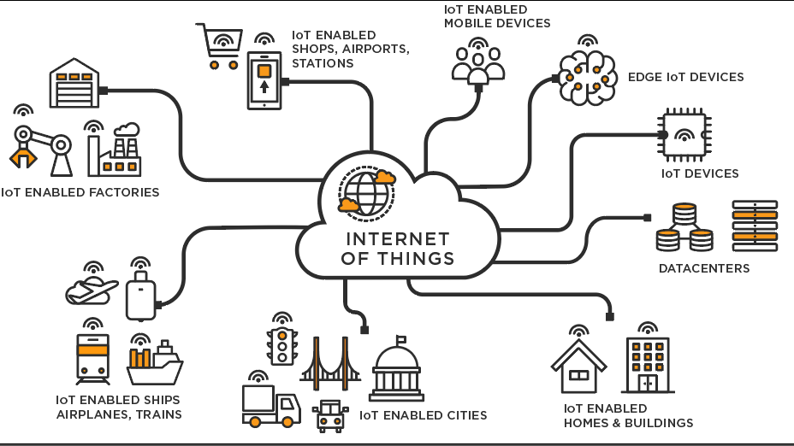
Figure 2-Diagram of IoT applications seen daily

1. Consumer IoT
Consumer IoT refers to personal and wearable devices that connect to the internet. These devices are often referred to as smart devices.
2. Industrial Internet of Things (IIoT)
The industrial Internet of Things is the system of interconnected devices in the industrial sector. Manufacturing machinery and devices used for energy management are a part of the industrial Internet of Things.
3. Commercial IoT
Commercial IoT refers to the tools and systems used outside of the home. For example, businesses and health care organizations leverage commercial IoT for auditable data trails and consumer management. (Schulze, 2025)

Pros vs. Cons of IoT

Pros | Cons
Efficiency and Productivity -  Automation of tasks | Many devices lack robust security
Enhanced data collection | Potential misuse of personal information
Cost savings | Reliance in technology can lead to issues if the internet connection fails
Smart homes and wearable health devices  provide personalized care and convenience. | Increased E-waste, and higher bandwidth demands on networks can cause slower speeds.
Table 2- pros and cons for IoT (CyberPolicy, s.f.)

The future of IoT

- Artificial intelligence and machine learning: AI and machine learning are becoming increasingly important for IoT, as they can be used to analyze vast amounts of data that is generated by IoT devices and extract meaningful insights.

- Blockchain: Blockchain technology is being explored to improve security and privacy in IoT. Blockchain can be used to create secure, decentralized networks for IoT devices, which can minimize data security vulnerabilities.

The field has evolved due to the convergence of multiple technologies, including ubiquitous computing, sensors, embedded systems, and machine learning. Traditional fields of embedded systems, wireless sensor networks, control systems, and automation independently and collectively enable the Internet of things.
In the Internet of Things (IoT), As of April 2026, the number of devices connected and controlled via the Internet has increased. Applications of IoT technology vary across devices, but many share common characteristics.
The IoT creates opportunities for more direct integration of the physical world into computer-based systems, resulting in efficiency improvements, economic benefits, and reduced human exertions. (Internet of Things: Wikipedia, s.f.)

Conclusion

While IoT has a lot of benefits and great solutions, it is important to consider its disadvantages as well, because in an era where internet is so necessary, there’s a lot of things at risks such as security breaches and privacy issues, even excessive reliance on internet related tools. But what is certain is that bigger things are coming for the Internet of Things and it will keep evolving based on new needs and innovative proposals, by the hand of Computer Science bases and tools, of course.

Bibliography
- CyberPolicy, I. (n.d.). Retrieved from https://www.cyberpolicy.com/cybersecurity-education/pros-and-cons-of-the-internet-of-things
- Internet of Things: Wikipedia. (n.d.). Retrieved from Wikipedia: https://en.wikipedia.org/wiki/Internet_of_things
- J, H., & Mithal. (2025, January). ResearchGate. Retrieved from https://www.researchgate.net/publication/387889850_Review_the_role_of_IoT_in_computer_scienceRICS
- Schulze, J. (2025, October). What is the Internet Of Things? With Examples. Retrieved from Coursera: https://www.coursera.org/articles/internet-of-things
- What's the Internet of Things? (IoT). (n.d.). Retrieved from IBM: https://www.ibm.com/think/topics/internet-of-things

